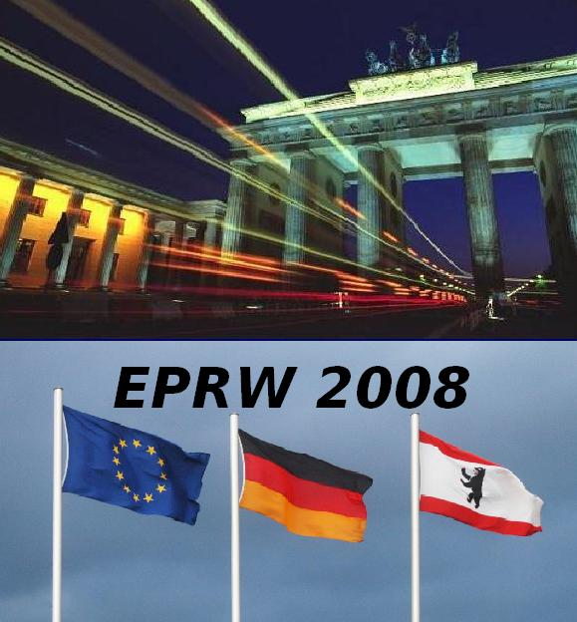

EPRW 2008 Secretariat
c/o Birgit Mueller

Federal Institute for Risk Assessment
PO Box 33 00 13
D - 14191 Berlin
Germany

_ Registration EPRW 2008 in Berlin, Germany
Pesticide Residues in Food and Drink, 1st to 5th June 2008

Please, fill in this form to register and send by e-mail to eprw2008@bfr.bund.de, by fax to +49-30-8412-3685 or as letter
Family Name
First Name(s) |  | Title
E-Mail
Organisation
Department
Mailing Adress
City & Postal Code
Country

 |  | Payment due (€)
Registration fee (until March 16th: 440 € , after 540 €) |  |  | €
Social Programme | No. of persons | Price p.p.
Conference Dinner: |  | á 50 € | €
Excursion 5th June: Potsdam Sanssouci: |  | á 60 € | €
Sightseeing Tour Berlin by Night: |  | á 15 € | €
 |  | Grand total | €

Please transfer payment to: | Federal Institute for Risk Assessment (BfR)
Name of Bank: | Deutsche Bundesbank, Filiale Kiel
Int. Bank Account Number (IBAN): | DE 4221 0000 0000 2100 1030
Bank Identifier Code (BIC or SWIFT): | MARKDEF1210
Reason for payment: | BFR EPRW < & Your name/names >
Important information: Registration will take effect only after payment was received. Separate transfers of registration fee and payment for social events are not preferred. Please ensure that all charges are for your account.

For payment from Germany, only: Deutsche Bundesbank, Filiale Kiel, BLZ: 210 000 00; Konto-Nr. 210 010 30

